User Guide
After loading all the information, it will show the Main Menu.
In this Main Menu page, you can choose different functions
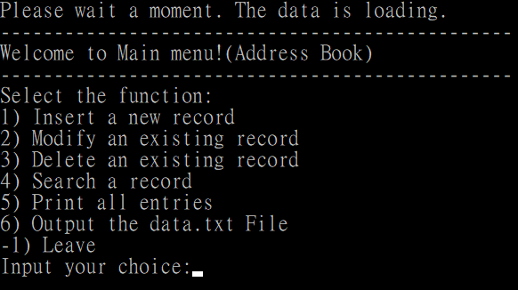

- Insertion Time Complexity O(logn), Space Complexity O(logn)
Insert a new record by typing all required data.
Example:
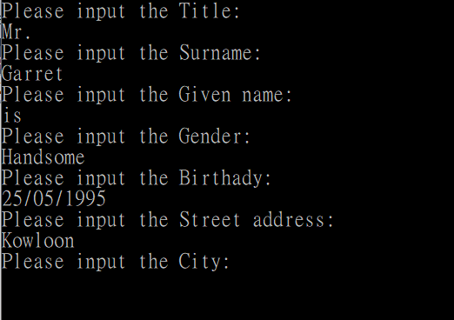
But the phone number should be integers only (0-9)!!!
After inputting all data, it will go back to the Main Menu.

- Modification Time Complexity O(logn), Space Complexity O(logn)
Modify by entering the phone number as the search key. If you don’t know the phone number of the record that you want to modify, then please jump to the search function first. You should use all the attributes you know to search the record that you want to modify. After you find the record, you should remember the phone number of the record which you will use for your modification.

After Entering the phone number, it will show all the information of the key. You can select the data that you want to modify. (Title/Surname/Given name, etc.)
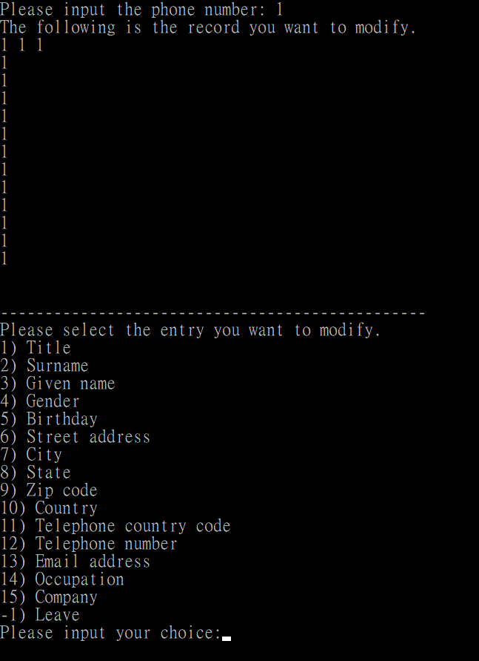
Input the attribute that you want to modify and input the new value.

After successful modifying, it will show a notification.
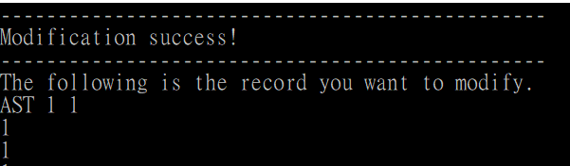
If the inputted key does not exist, it will show a notification and go back to the main menu.
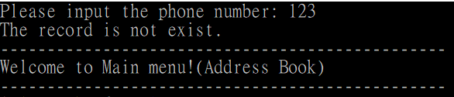

- Deletion Time Complexity O(logn), Space Complexity O(logn)
Deletion by entering the phone number. If you don’t know the phone number of the record that you want to delete, then please jump to the search function first. You should use all the attributes you know to search the record that you want to delete. After you find the record, you should remember the phone number of the record which you will use for your deletion.

After deleting the data, it will show a notification and go back to the Main Menu.
If the inputted key does not exist, it will show a notification and go back to the Main Menu.

- Searching Time Complexity O(logn) OR O(n), Space Complexity O(logn) OR O(n)
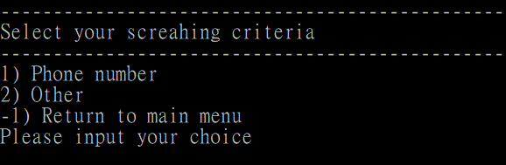
Choice: 1 Time Complexity O(logn), Space Complexity O(logn)
Search by phone number:
After entering the phone number, it will show the information and go back to the Searching Menu to search other data or go back to the Main Menu.
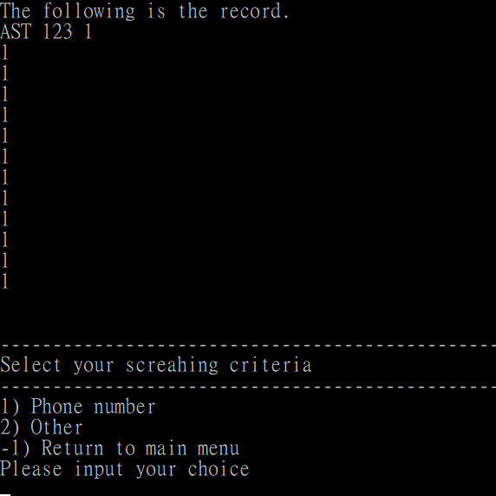
Choice: 2 Time Complexity O(n), Space Complexity O(n)
Search by other criteria (all 14 data without the phone number):
Input the information that you know, if not input -1.
All the data that match the inputted criteria will show. (if you input Mr. only and input other criteria as -1, then all records with Mr. as title will show)
As you can see, we have 2^14 combinations of criteria for searching.
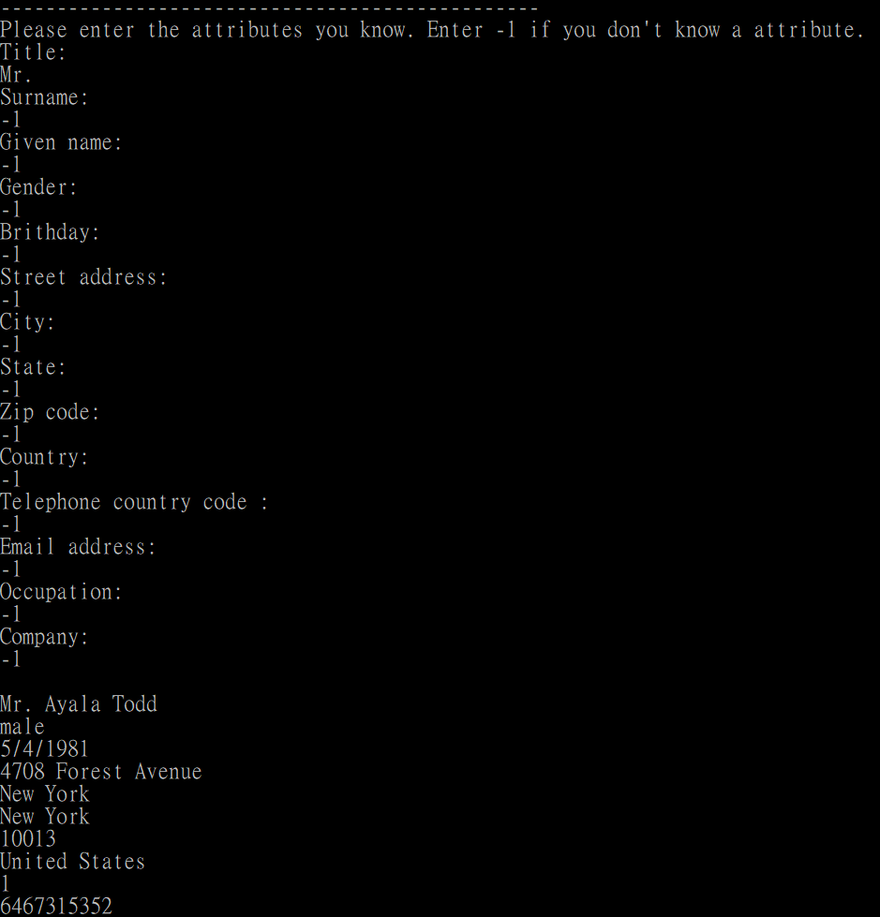
Choice: -1
Back to Main Menu

5. Print all records Time Complexity O(n), Space Complexity O(n)
Before printing, it will ask you to continue or not. (Because printing all the information will spend a lot of time.)

If yes, all information will be printed out. Then, go back to Main Menu after finishing the printing.
If not, it will directly go back to Main Menu.

- Output Time Complexity O(n), Space Complexity O(n)
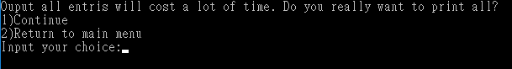
Before outputting all the data, it will ask you to continue or not (Because output all the information may spend a lot of time.)

When outputting the data, it will show a notification asking you to wait a moment.
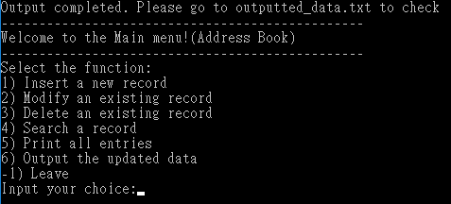
After outputting all the data, it will go back to Main Menu and show it is completed.
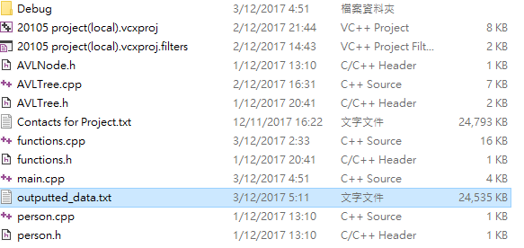
The “outputted_data.txt” is in the same folder with AVLNode.h and AVLTree.cpp, etc.
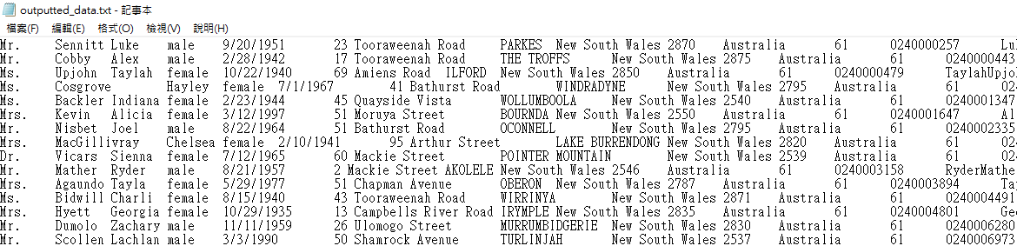
All the data will be outputted to “outputted_data.txt” and the data will be sorted by the phone number with ascending order, the data should be in the same format of “Contacts for Project.txt

